Impact of mannitol and poly ethylene glycol 6000 induced water deficit on plant biomass and major secondary metabolites in Centella asiatica (L.) Urb. in vitro
Jisha S, Aiswarya S, Gouri PR, Manikantan K & Sabu KK*
Biotechnology and Bioinformatics Division, Jawaharlal Nehru Tropical Botanic Garden and Research Institute, Palode, Thiruvananthapuram, Kerala, India

Supplementary Data

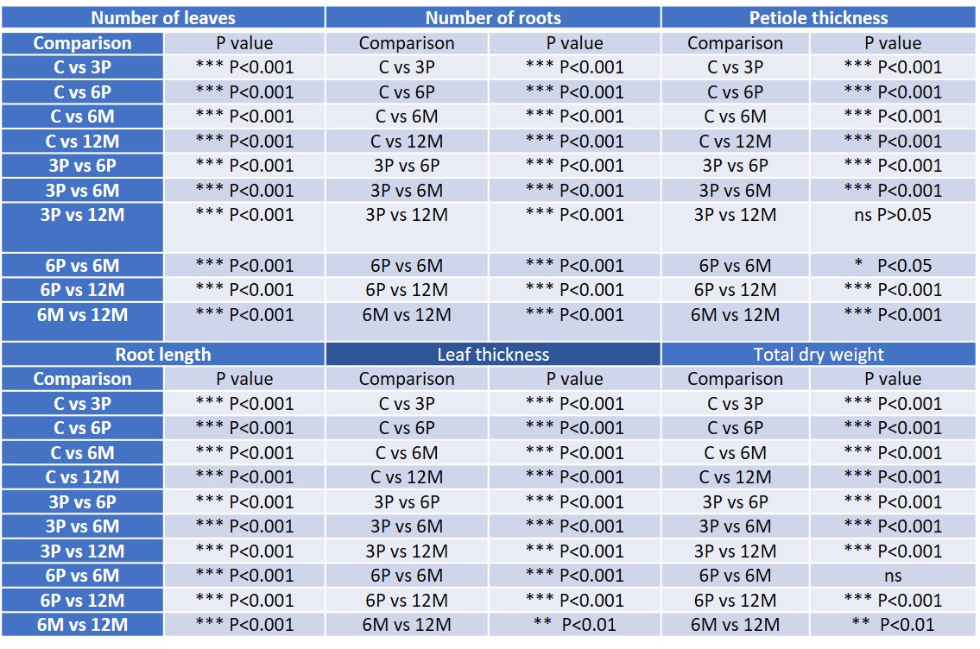

Suppl. Table S1 — Level of significance in each using Graphpad Instat 3

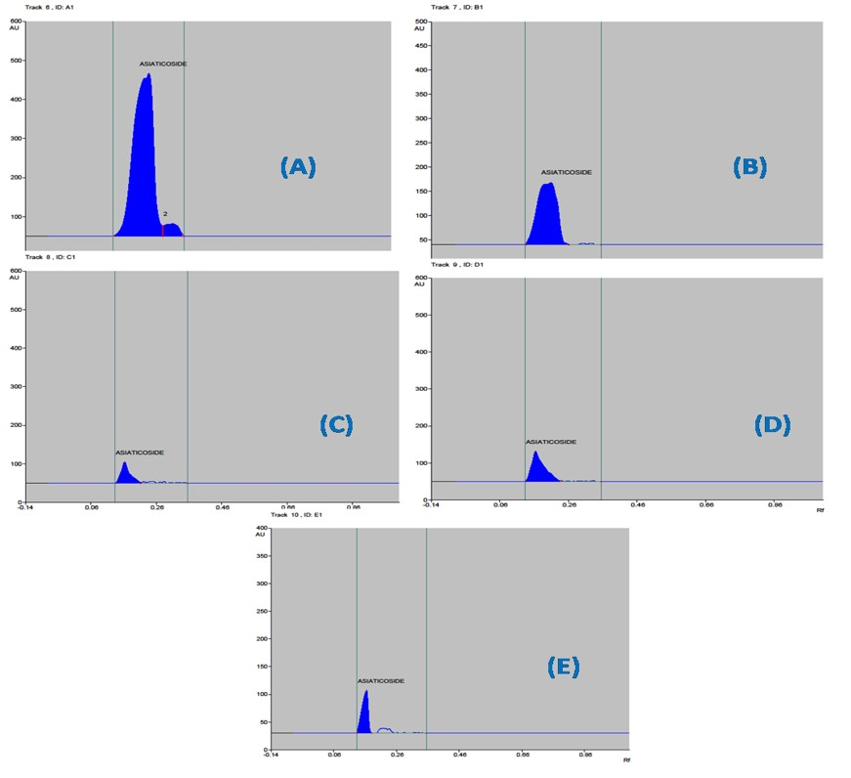

Suppl. Fig. S1 — HPTLC Chromatogram of extracts from (A) control in vitro culture; (B) C. asiatica with 3% PEG 6000; (C) with 6% PEG 6000; (D) with 6% mannitol; and (E) with 12% mannitol
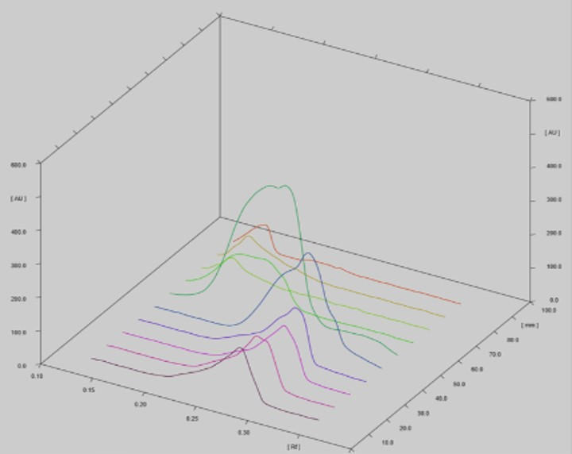

Suppl. Fig. S2 — 3D densitometric chromatograms obtained from HPTLC analyses from different concentrations of asiaticoside, control in vitro culture, C. asiatica with 3% PEG 6000, with 6% PEG 6000, with 6% mannitol and with 12% mannitol.

