Fog. 1



Fig. 2

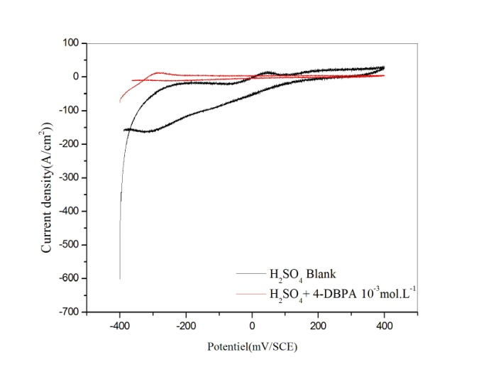

Fig. 3

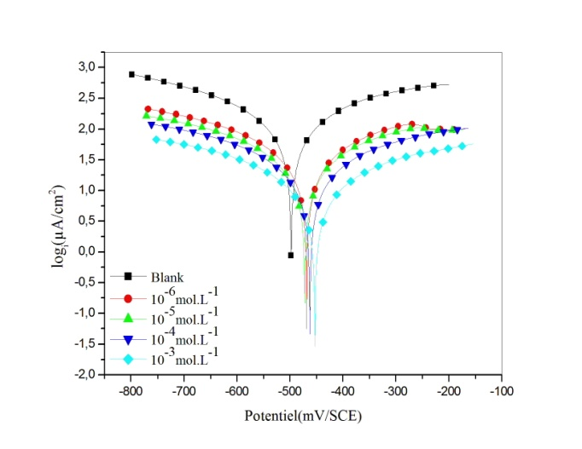

Fig. 4

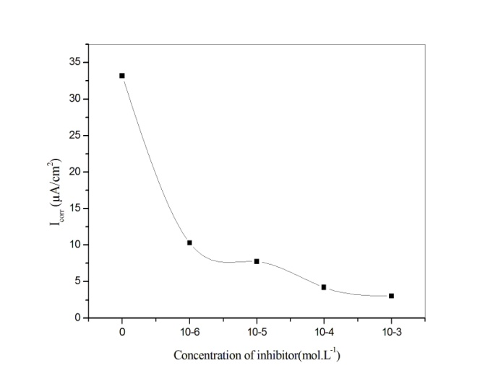

Fig. 5

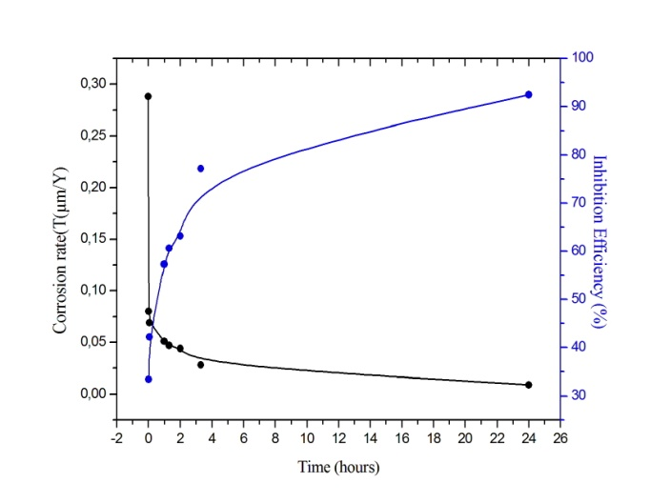

Fig. 6

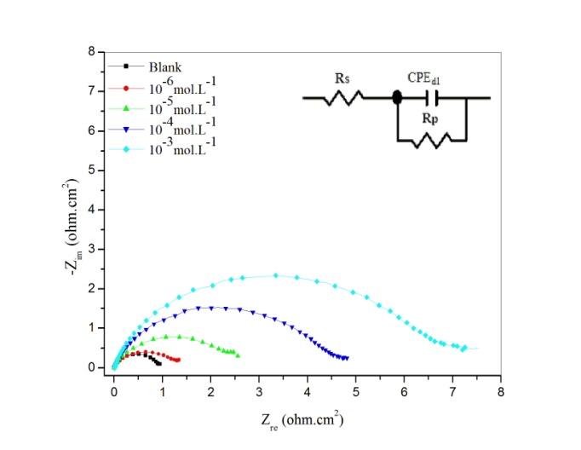

Fig. 7

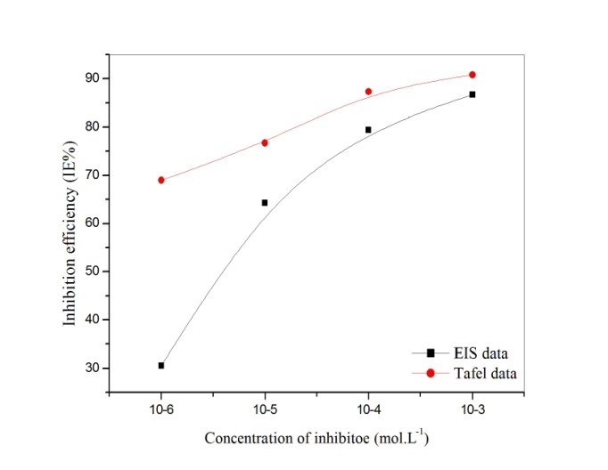

Fig. 8

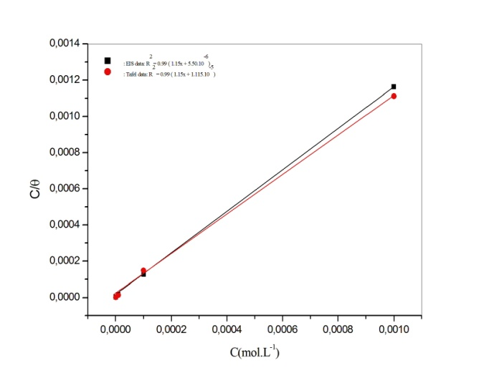

Fig. 9

|  |
| --- |
| C:\Users\toshiba\Desktop\R. KERKOUR Calculs\P4\Gas phase\Optimized strucure.tif  (a)Optimized molecular structure |
| **C:\Users\toshiba\Desktop\R. KERKOUR Calculs\P4\Gas phase\HOMO.tif**  (b) HOMO |
| **C:\Users\toshiba\Desktop\R. KERKOUR Calculs\P4\Gas phase\LUMO.tif**  ( c) LUMO |
| C:\Users\toshiba\Desktop\R. KERKOUR Calculs\P4\Gas phase\Electron density from total SCF density mapped withe ESP.tif  ( d) MEP |

Fig. 10